

BUMK770: Retail Analytics

Case Analysis I: Marsh Supermarkets

Professor Jie Zhang
Group D

Heven Abraha
Nia Bishop
Victoria Rush
Julia See

Monday, April 13, 2026

By including my name on this work, I certify that I have been an active team member.

Honor Pledge:

We pledge on our honor that we have not given or received any unauthorized assistance on this project.

Executive Summary
This report evaluates the performance of the Health and Beauty Care (HBC) department at Marsh Supermarkets and identifies opportunities to improve profitability through category management decisions. While perishables remain the primary driver of store traffic and sales volume, the HBC department plays a strategic role as a margin leader, consistently generating 25-30% gross margins and strong returns on inventory investment. Despite contributing a smaller share of total basket spend, HBC drives a disproportionate impact on net profit due to its high Gross Margin Return on Inventory Investment (GMROII). However, performance is constrained by ineffective store placement that reduces impulse purchases, high inventory in underperforming categories, and increased competition from mass merchandisers, which threatens price-sensitive consumers. Marsh Supermarkets can remedy its performance by reallocating shelf space and inventory toward high-margin, high-turnover categories such as diet aids and baby products. Product placement optimization at eye-level shelves will enhance visibility and drive impulse purchases. Marsh Supermarkets can strengthen the profitability of the HBC department while reinforcing store performance by streamlining assortment, improving inventory efficiency, and prioritizing high-return categories.
Introduction/ Background
Marsh Supermarkets’ financial performance in 1990 and 1991 reflects a typical grocery retail model, where profitability is driven more by volume and efficiency rather than high profit margins. Using data from Exhibits 1 and 2 (Marsh Supermarkets, Inc. (A): The Marsh Super Study) Marsh’s net profit margin increased slightly from about 1.07% in 1990 to 1.17% in 1991, showing only a slight improvement when it came to profitability. At the same time, asset turnover declined slightly from roughly 4.22 to 4.0, suggesting the company generated slightly less sales per dollar of assets than the year before. When combining these measures, return on assets (ROA) improved marginally from about 4.52% to 4.68%, indicating that overall performance gains came primarily from better margin control rather than improved efficiency. These findings highlight that Marsh operates in a low-margin, high-volume environment, making it critical to manage individual product categories, such as Health and Beauty Care.
Overall Strategies
Marsh’s positioning in the Indianapolis market is a service-focused supermarket that competes on convenience, assortment, and in-store experience rather than purely on price. While competitors like warehouse clubs and mass merchandisers attract customers with lower prices, Marsh delivers value by offering one-stop shopping, a wide selection of products, and a more customer-friendly environment. This is especially important in the HBC category, where competition is intense and alternative retailers are expected to capture a large share of sales. Marsh uses a high/low pricing strategy, where certain HBC products are promoted through discounts, displays, and advertising to drive both traffic and incremental sales. The store also includes private-label options, allowing Marsh to maintain margins while still giving customers variety. (Exhibit 3, Marsh Supermarkets, Inc. (A): The Marsh Super Study).
Marsh would not effectively increase profit margins by targeting all three consumer groups. Marsh’s competitive positioning would be weakened by trying to market to various consumer categories, given their different purchasing behaviors. Instead, Marsh should focus on routine and fill-in shoppers. Fill-in shoppers make quick, convenience-driven trips for essential items and spend less time in-store. In contrast, routine shoppers generate consistent traffic and are more likely to purchase higher-margin items such as HBC products. Stock-up shoppers are traditionally considered loyal, but they only represent 16% of customers and are highly price-sensitive, often turning to competitors for discounts. Marsh should prioritize routine shoppers who would be heavily influenced by promotions, loyalty programs, and the consistency provided by Marsh after the introduction of several competing mass merchandisers and wholesale clubs in the Midwest market. Marsh can strengthen its core customer base and indirectly encourage greater long-term loyalty across segments.
Merchandise Department Analyses
The strategic role of the HBC Department at Marsh Supermarkets primarily focuses on profit generation. HBC contributes a secondary role in maintaining store image while delivering high margins and strong returns on inventory investment. The GMROII calculation of 1.66 annually (0.032 weekly) represents that for every dollar invested into HBC products, Marsh earned approximately $1.66 in gross margin. Various product categories serve distinct roles. High-margin, high-turnover categories such as diet supplements/vitamins and baby products function as profit generators while maximizing shelf space. Personal care products such as skincare, cosmetics, oral hygiene, hair care, etc., contribute to sales generation due to constant purchases and strong markups. Consistent profits are also increased due to less perishability with HBC products. Marsh’s convenience positioning is supported by the sale of HBC products, encouraging shoppers to purchase all items in a single trip without visiting competing retailers. The placement of products in heavy-traffic aisles or near the pharmacy is based upon strategic store layouts, while adding seasonal store displays to drive profits. The HBC department strengthens Marsh’s financial performance by optimizing margin contribution while reinforcing the store’s image as a convenient shopping destination.
Our analysis indicates that while Perishables drive store volume, the HBC department serves as a vital “margin protector.” Data from Exhibit 3 shows that despite lower sales volume, Health and Beauty Care maintains gross margins between 25% and 30%, which is significantly higher than the store average. By assessing GMROII, we found that Health and Beauty Care’s high-value, small-footprint items generate a superior return per shelf foot compared to bulky, low-margin commodities. This stability was evident during the 1991 recession; while shoppers traded down on food, essential personal care spending remained steady, securing departmental profitability.
When compared to store-wide averages, HBC’s strategic value lines contribute to net profit. A typical household “basket” allocates roughly $15 to groceries and only $5 to Health and Beauty Care; however, that $5 yields higher margins with lower overhead. This highlights a clear opportunity to improve “inter-category purchase correlation,” capturing more Health and Beauty Care sales from customers already visiting for high-traffic perishables.
Despite these financial strengths, Exhibit 5 ‘Store Layout and Traffic Patterns’ reveal significant layout inefficiencies, with Health and Beauty Care products frequently located in “dead zones.” Since shoppers treat these aisles as “mission-driven” trips rather than for browsing, placement away from the “Power Perimeter" (milk, meat, eggs) results in lost impulse buys. To defend against “category killers” like Wal-Mart, Marsh must leverage its convenience advantage by rationalizing SKU proliferation and removing low-turnover products that negatively impact inventory and marginal productivity.
Recommendations
The product categories of Marsh’s HBC vary in performance, which impacts product assortment, shelf space, and inventory metrics. Baby prep and diet aids should be expanded in all three aspects. These two product categories have the highest GMROI and DPPROI levels, indicating they are strong profit drivers despite their lower sales volumes. Currently, both these products only occupy 0.07% of shelf space, yet they lead the HBD in inventory turn (9.33 and 13.36, respectively) and operate with the lowest days of supply across the department (39.01 and 27.26). Furthermore, Baby Prep also generates a weekly DPP per foot of $5.47, the highest in the department, suggesting that its shelf space is very valuable and justifies an expansion. By expanding both of these products' shelf space, it will maximize the profitability of these products and reduce out-of-stock risks that are currently present. This action would also reduce labor costs by decreasing the frequency of restocking.
Foot care and cosmetics should be reduced in terms of their shelf space, SKUs, and inventory. Foot care represents 0.03% of total department sales and has a DPPROI of only $0.17, the lowest in the department, yet it occupies 0.15% of shelf space. Likewise, cosmetics have the highest share of total shelf space (5.18%) and SKU stocking (12.03%), yet produce weekly sales that are extremely low at $0.69. Compared to laxatives ($34.50), this presents a huge opportunity cost that can be allocated to other categories. Additionally, both these category groups, along with their low GMROI ($0.97 and $0.40), have high days of supply (214.78 and 450.31), meaning they're taking up physical space without providing ample returns. Reallocating this space to baby prep and diet aids would improve the department's overall performance.
The remaining categories of the HBC should be maintained. Specifically, categories of antacids, hair care, and oral hygiene, which serve as financial must-haves for Marsh. While not an extreme profit driver for the department, these product groups each have almost 0.5% of total dollar sales, indicating their value and that their removal would risk redirecting customers to competitors.

Appendices
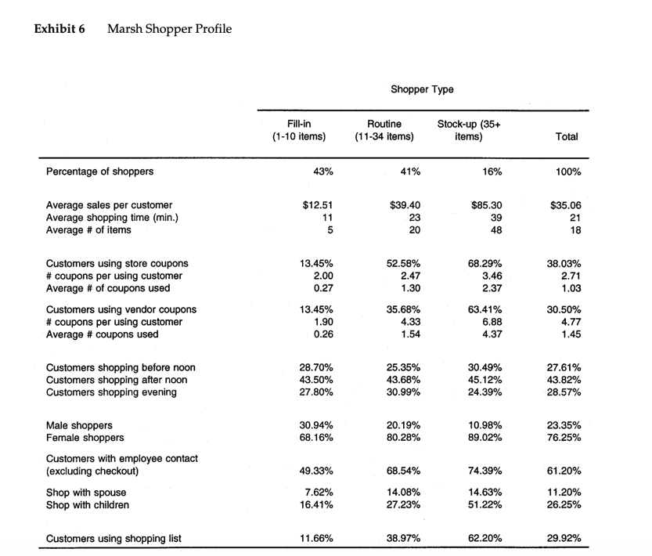
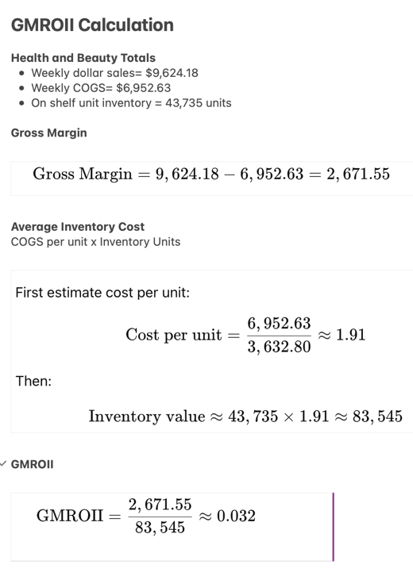
Figure 1: Consumer Shopper Profiles Figure 3: GMROII Calculation

Figure 2: Marsh Overview Report for Health and Beauty Department
